Water Drinking Timer Arduino Project

Kevin Truong

ECE 101

Colorado State University​​

1. Abstract

The purpose of this project was to create a device that can track liquid level, status, and presence in a cup. With the data collected by the various measurements, the device would then calculate the time taken to drink a full cup of liquid (eg. water, soda, or beer). Using an Arduino microcontroller and other various electronic components, the device would measure the presence of liquid in a cup and determine if a user is drinking from the cup and time how long it may take them to drink all the liquid from the cup.

2. Introduction

Arduino is an open-source project that designs and manufactures microcontrollers and kits for creating electronic projects utilizing different various electrical components and modules. Arduinos are designed for artists, students, hobbyists, and anyone interested in creating DIY electronic projects. They are very user-friendly coming with many different forms of documentation, example projects, and templates to get people started on their electrical creative journey.

3. Technical Approach/Project Idea and the use of each component

Beginning this project my plan was to create a device that could be used as a game of sorts that can measure the amount of time taken to drink a full cup of liquid and show how many times a full cup has been consumed. The purpose of the device was to provide entertainment and possibly a game to play among friends to compete in how fast they can drink.

The first hurdle of this project was figuring out what components were needed to build this project. The first component that I needed was a sensor to determine if the cup is filled with water so I did some research the only thing I could find was a water level sensor but it was about $80 which was a little out of the budget for this project so I did some more digging and found that you can make a sensor that can measure capacitance with just a resistor and tinfoil. Though this sensor was a lot less accurate and a bit buggy it was really the only option I had so I made due.

While testing out the capacitance sensor I realized I needed a better way to understand the measurements coming from it so I acquired an RGB LED to indicate the different states that the cup could be in based on the amount of capacitance the sensor was reading. Since the sensor was not that accurate the only real states I could read from just the sensor alone was whether the user was drinking from the cup or not. This meant the aspect of being about to tell how many full cups of liquid you have drunk was not a possibility for I could not tell how full the cup was or if it was full at all.

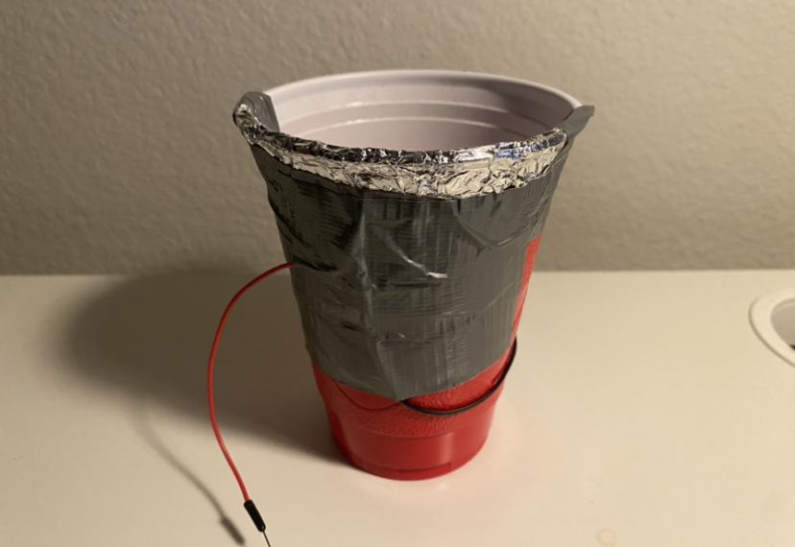

Once I configured the sensor to a cup and coded the logic for understanding the capacitance and if the user was drinking from the cup or not I then changed the color of the LED based on the state of the cup. This was when I realized that the sensitivity of the sensor varied a lot because of the temperature of the room, temperature of a person, the capacitance of a person, and many other things so wanted a way to change the sensitivity and calibrate the device for every person. A button was added to enable a calibration mode where the person would hold the cup and the sensitivity would be set to the base level of someone’s capacitance. Also since there was already an LED on the device I realized I could make a sort of countdown that could tell a user when to start drinking to add more the game aspect of the device so I also added a button for that.

After I had set up the sensor, LED, and buttons I started coding and was able to make it pretty functional and accurate. I had a button to calibrate sensitivity, a button for a countdown, and the LED indicated the state of the cup pretty accurately based on the sensor data. All that was left was to figure out how to time each drink. I coded up the timer with the start condition being the cup in a drinking state and the stop condition as when the user stopped drinking from the cup. With that, I had all the core components of my game.

The last component I added was a screen that could display the time of a drink so people didn’t have to read the serial monitor on my laptop to know their score. I also included the screen calibration values to provide better accuracy of the calibration.

Finally, I clean up the wiring, cleaned up my code and optimized it to get better readings from the sensor, and made a little title sequence on the screen to make it more visually appealing and fun. Also in the code, I added a setting that you could set to true or false depending on the configurations of the device you wanted.

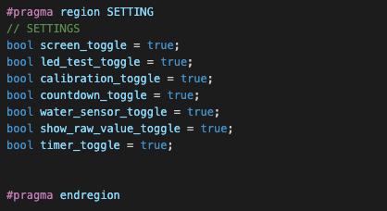

4. Conclusion

In conclusion, this project tough me a lot about the various aspects of electrical engineering. This being my first time ever using an Arduino it was a lot of fun and I learned a lot. I learned how to create a sensor with only tinfoil and a resistor and understand the raw data coming from the voltage readings of the sensor. I learned how to use an OLED screen and display text and animations. Browsing the many libraries of the Arduino I found millions of functions that could be done using an Arduino expanding the realm of possibility that a microcontroller can provide to real-life applications. I also learned to use the many different tools and phases of the engineering method, specifically concept and design because I had to design some interesting logic to get the sensor to work and in an applicable manner.

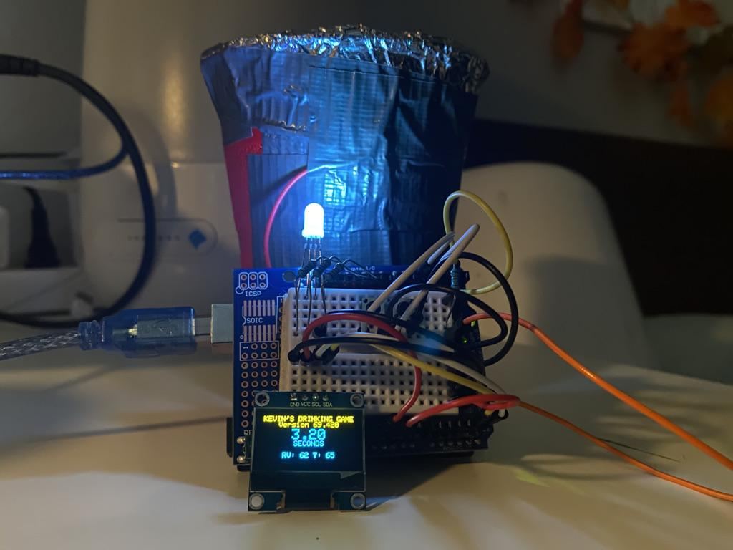

5. References

<https://www.arduino.cc/reference/en/libraries/rbd_watersensor/>

<https://randomnerdtutorials.com/guide-for-oled-display-with-arduino/>

<https://github.com/ArduinoGetStarted/button>